The JC
Health department announces new ‘opt-out’ organ donation system will be introduced in May
By Aleks Phillips
February 26, 2020 16:15
The new regulations were warmly received by the Union of Orthodox Hebrew Congregations, but the Federation stayed silent on the matter
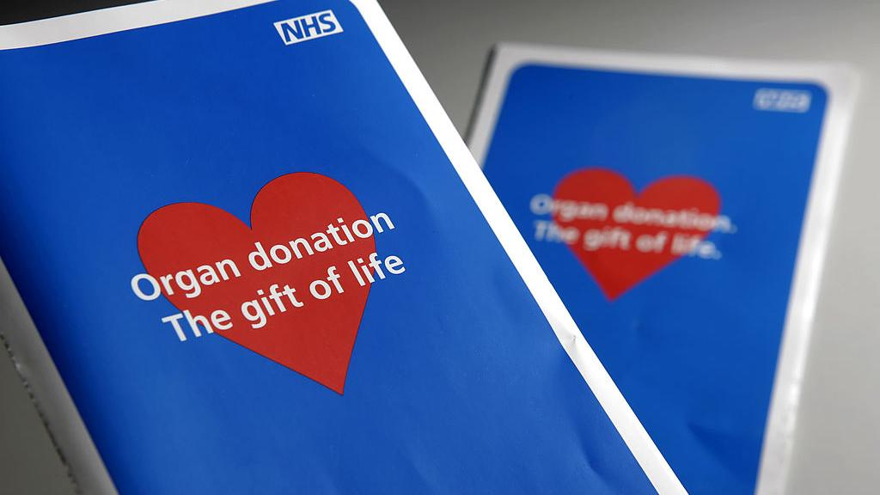An 'opt-out' system for organ donation is to be introduced in the spring (Photo: Getty Images)
The announcement by the Health Department on Tuesday that a new opt-out system of organ donation will come into effect on May 20 has been met with a mixture of positive statements and silence from the UK's Orthodox leadership.
The new regulations were introduced to Parliament on Tuesday following the passing of the Organ Donation (Deemed Consent) Act – otherwise known as Max and Keira’s Law – last year.
The new system means that any person over the age of 18 who has lived in England for more than a year will be presumed to have consented to their organs being donated after they die, unless they state otherwise.
According to the new regulations, a refusal of consent can be lodged through the NHS Organ donor register, but also done in writing or to a family member.
Following a consultation on practical guidance for healthcare professionals by the Human Tissue Authority (HTA) last summer, family members will be consulted and a person’s religious beliefs will be taken into account, before an organ donation goes ahead.
Although there are a number of interpretations of the halachah on organ donation, most Charedi rabbis consider it against Jewish law.
A recent poll of over 1,000 British Jews by the Jewish Organ Donation Association (Joda) found that there was “significant confusion” over organ donation. Just under half of respondents see Judaism’s position to be “unclear” or “very unclear”.
Mr Shlome Sinitski, who represented the Adath Yisroel Burial Society and the Union of Orthodox Hebrew Congregations (UOHC) during the consultation, told the JC: “The HTA has engaged extensively with the Charedi community on the new law and particularly the updated code of practice.
“Organ donation is a sensitive matter and we are reassured that the religious and cultural needs of the Charedi community are taken well into account. We encourage families to have discussions on this matter and to consider recording their views on the Organ Donation Register.”
Rabbi Yaakov Conrad, registrar of the UOHC’s rabbinate, told the JC that it was a positive announcement, adding that “in most cases I think people would be advised to opt out,” but that the rabbinate “don’t want to make a general ruling on the subject”.
According to Rabbi Conrad, the rabbinate did not want to say that Jews should not donate organs when there are situations in which they should, such as to save someone else’s life.
The Beth Din of the Federation of Synagogues declined to comment on the news, but has previously disputed the UOHC’s warm reception of the new law. Dayan Yisroel Yaakov Lichtenstein claimed in November that “if family members seek to prevent the donation of the deceased’s organs, they will have to provide proof that the deceased expressed their opposition to the donation.”
Eddie Hammerman, Director and co-founder of the Jewish Organ Donation Association, told the JC that it was an “unfounded belief” that “one needs to be whole to be buried in a Jewish cemetary or that a body needs to be intact for the coming of the Messiah.
“By all halachic teachings these are untrue. We have found that Jewish law is supportive of the preservation of life and organ donation.”
He added: “We welcome the confirmation of the date for the implementation of the 'deemed consent' system. Our survey shows that Jews are extremely supportive of organ donation but there is confusion around what is possible within the framework of Jewish law.
“There are some pockets of the Jewish community who have reservations but we hope that this will change as we continue to engage with leaders to discuss the issues in further depth.
"Saving a life (Pikuach Nefesh) is fundamental to Jewish teachings, so having open conversations with friends and family about your wishes is so important ahead of the law change in May.”
The draft regulations presented to Parliament on Tuesday set out organs and tissues which will not be part of the opt-out system.
Whilst routine transplants of organs and tissues, including hearts, livers and kidneys, will come under the new law, novel and rare transplants will continue to require express consent.
In a statement, Health Secretary Matt Hancock said: “Too many people lose their lives waiting for an organ, and I’ve been determined to do what I can to boost organ donation rates.
“So I’m incredibly proud of the action we are taking with this new law. This is an important step forward in making organ donation easier and more available to those who need it and could help save hundreds of lives every year.”

